**Annual report**

**of NSS for the**

**session 2023-24**

**In r/o GSSMS**

**BSL PROJECT**

**SUNDER NAGAR**

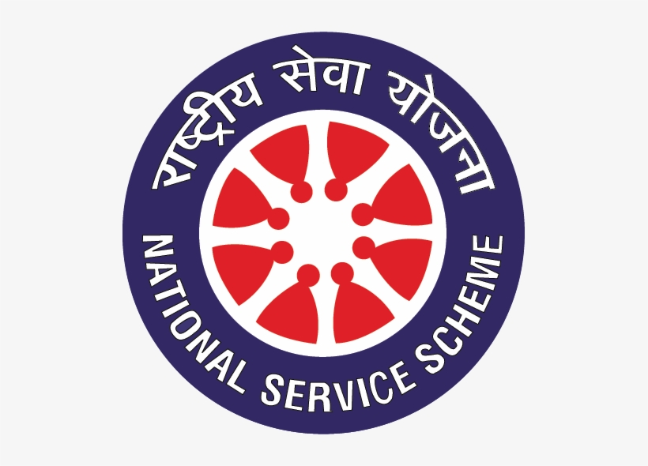

SERVICE IS THE SILENT ARCHITECT OF A BETTER SOCIETY SHAPING A FUTURE WHERE COMPASSION BUILD BRIDGES

NSS IS NOT JUST AN INITIATIVE. ITS A COMMITMENT TO SOCIETAL WELL BEING AND PERSONAL GROWTH

With the commencement of this session the students from classes 11th and 12th were enrolled as NSS volunteers 69 students were enrolled as NSS volunteers.

The advisory committee was framed. In this advisory committee Principal

Mr. Manjit Singh was the Chairperson, Mrs. Sumeet Sharma Lect. in Eng. was the Programming Officer and Secretary Mr.Tilak Naik (D.M.), Mrs.Vidya Devi

(Tgt Arts) Mrs. Raksha Dhiman Ward member of Municipal Committee , students of class 12th Miss Tanisha and Master Kartik Sharma were the members. Cleanliness drive in school was organised.

On 5th June Environment Day was celebrated in which NSS volunteers participated in essay writing competition and poster making competition. Rally was also organised for awareness campaign.

International Yoga Day was celebrated in the school in which NSS volunteers also participated

On 15TH August Our NSS volunteers also took part in Parade organised in GSSS BSL PROJECT Sundernagar

NSS volunteers also celebrated NSS Day on 24th September by organising one day camp in which they awared their juniors about the importance of casting vote. NSS volunteers also participated in Essay writing competition on the topic 3 R’s on dated 30th September 2023.

Swachhata Pakhwada was observed on 2nd October 2023 in which volunteers cleaned School Campus, BBMB Hospitals and Children parks.

One day camp was organised on the occasion of Children Day on 14th November 2023 in which volunteers participated in different games and cultural programs.

Constitution Day was celebrated in the school on 26th November 2023 in which lectures were delivered on concerned topics and volunteers participated in declamation and debate competition.

NSS volunteers also participated in AIDS awareness campaign on 1st December 2023. NSS volunteers also participated in Parade on Republic Day.

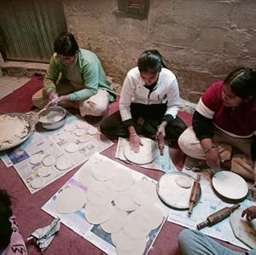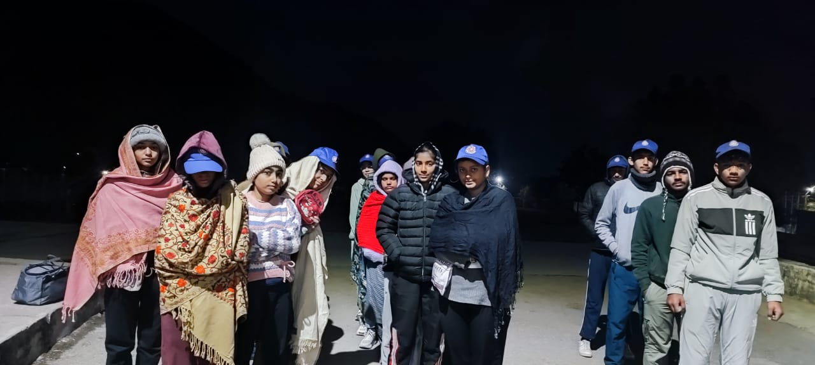

**PRABHAT PHERI PREPARING BREAKFAST**

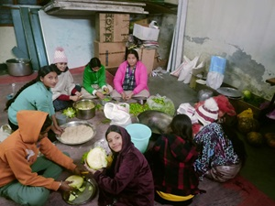 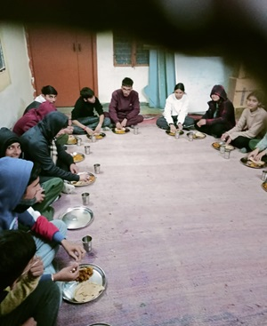

**PREPARAION FOR DINNER LUNCH TIME** 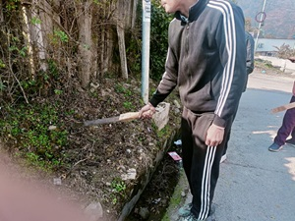 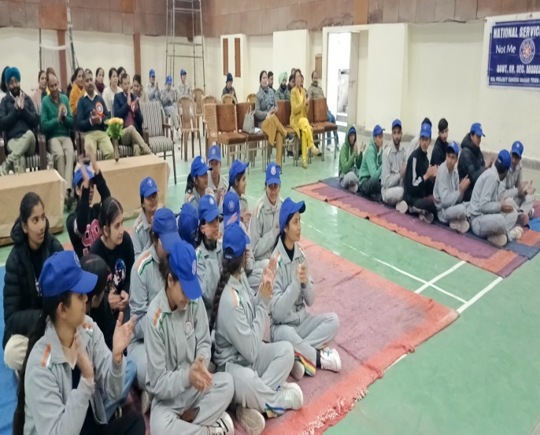

**CLEANLINESS DRIVE CLOSING CEREMONY**

**SEVEN DAYS SPECIAL CAMP**

**(15th DEC 2023 TO 21st DEC 2023)**

NOT ME BUT YOU was the main motive of this camp

Seven days special camp was organised in the school campus under the leadership of NSS Programming Officer Mrs. Sumeet Sharma, embodying the spirit of community service in which 36 NSS volunteers participated. Opening ceremony was inaugurated by Mr. Manjit Singh Principal GSSMS BSL PROJECT Sunder Nagar.

Prescribed schedule was observed during this camp. The day started with Prabhat pheri. Other events were Cleanliness drive, rallies and lectures by different distinguished personalities.

The unit performed many activities like awareness program. Lectures regarding literacy, rallies, tree plantation health and hygiene, Cleanliness, First aid, disaster management, communal harmony teamwork, hazards of smoking, drinking, drug addiction, knowledge about safety rules were delivered by distinguished guests.

During this camp all NSS volunteers stayed in the campus day and night. Different cultural programmes were also organised during this camp. In the closing ceremony Superintending Engineer Er. Ajay Pal was the Chief guest who graced this ceremony with his presence. Other esteemed guests of the day who graced this closing ceremony with their presence were Er. S.P. Sharma, Er. Chander Mani Sharma. The Chief guest showered his blessings on all NSS volunteers and appreciated their team work and social service.

BEST REGARDS SUMEET SHARMA

PRINCIPAL Programming Officer